# Guidance on Focus Length Measurement

Pan Feng, email

In this profile, I will describe how to get a special parameter of the camera. The parameter is called cameraDist in the program.

As is shown in this picture,

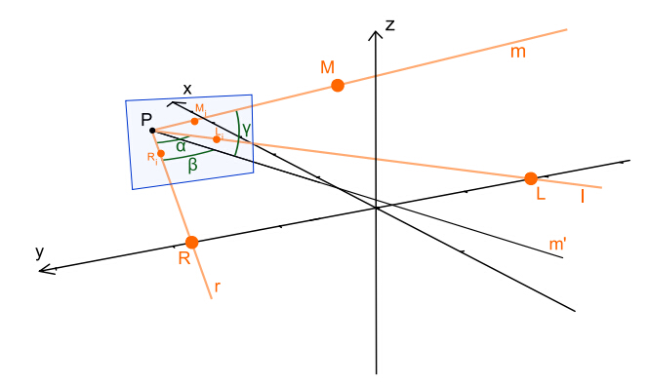

Fig. 1 Geometric measurement of the camera frame and local frame.

P is the position of the camera and the blue screen is the imaging plane. We need to know the distance between point P and imaging plane so that we can calculate the three angles α,β,γ. So the distance is a very important parameter. cameraDist is the parameter. But the parameter is likely to change along with the focal length or lens calibration parameters. If you meet such amendment, you can use the matlab program to calculate the parameter again.

Then it’s time to talk about how to use the matlab program.

Step one: set some parameter in the program, including screen length, screen width, and d_MO and d_LR.

Step two: use the camera to take a photo of the markers, and note the actual coordinate of the camera.

Step three: comment the coordinate of LRMS with ‘%’ in the photo. Then write the coordinate in the program like the following picture

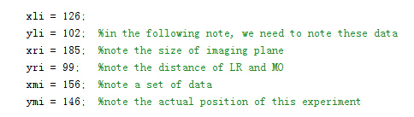

Fig. Comment this block before set new parameters.

Step four: set the start and end of cameraDist parameter and run the program

Step five: choose the most suitable number so that the coordinate of P is very close to the actual coordinate. And note the number as the cameraDist。

p.s. According to my own experience, the parameter cameraDist is between screen length and screen width. As for pixy, its screen length is 318, and screen width is 198. As a result, the cameraDist is between 198 and 318.